

CS353 DATABASE SYSTEMS

2018-2019 SPRING SEMESTER

**SCENEZ**

PROJECT PROPOSAL

GROUP 19

Dawood Muzammil **MALIK**

Masna **AHMED**

Muhammad Umair **AHMED**

Talha **ZEESHAN**

Contents

**1.** **Revised ER Model** 4

**2.** **Relational Schemas** 6

**2.1** **Entities** 6

**2.2** **Relationships** 10

**3.** **Functional Dependencies and Normalization of Tables** 17

**4.** **Functional Tables** 17

**4.1 Use Case Scenarios** 17

**4.2 Algorithms** 29

**4.3 Data Structures** 29

**5.** **User-Interface Design and corresponding SQL statements** 30

**6.** **Advanced Database Components** 34

**7.** **Implementation Plan** 34

**8.** **Website** 34

# **Revised ER Model**

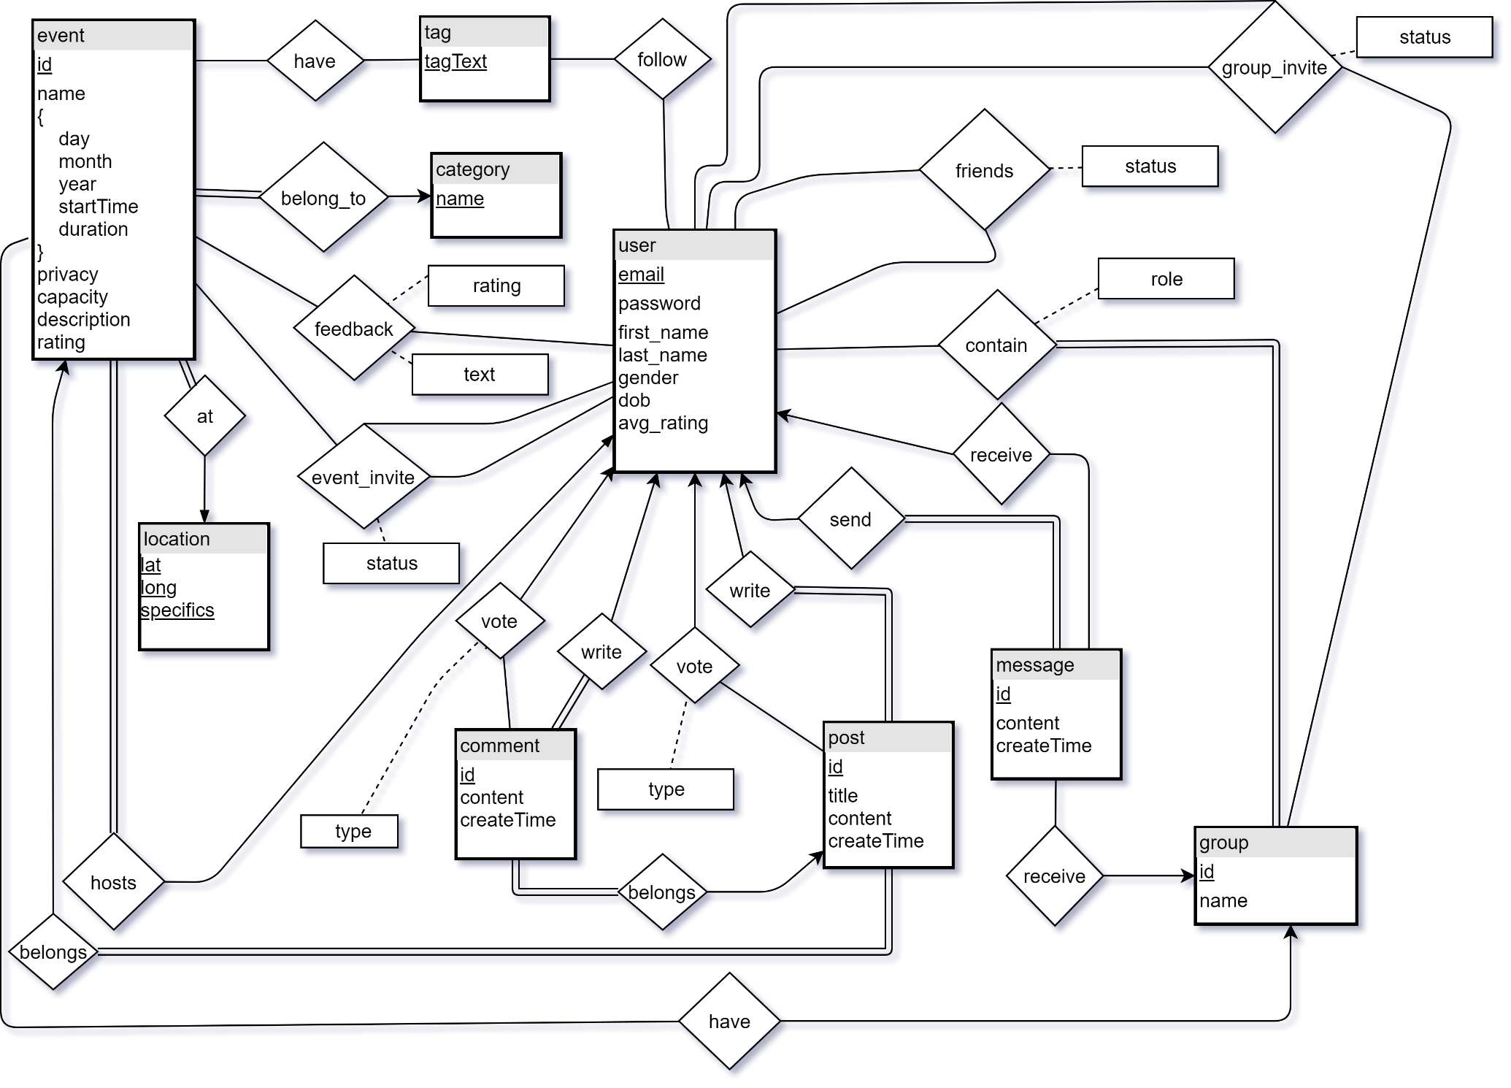

* Some new attributes have been added to the *users* entity to store more information about the user.
* A *follow* relationship has been added between *tags* and users to store the tags followed by specific users.
* The separate entities named *event_comments* and *group_comments* were deleted and a single entity *comment* was added. The rationale behind this was to eliminate all possible weak entities.
* For the purpose of reducing complexity, entity named *group_posts* is now deleted. Posts now only belong to events (*post-belongs-event)*.
* Entities named *creates* and *contain* were merged into a single entity (*contain*) with a single attribute named role associated with it. This was done to avoid unnecessary duplication of data records.
* An extra attribute (*text*) was added on the *feedback* relationship between *user* and *event*. This will allow the users to give textual feedback on the events they attend.
* Deleted the ternary relationship *belongs_to* as it was an incorrect representation of a ternary relationship.
* *Groups* are now linked to *events* through a *have* relationship. The rationale behind this change is that there could be some events that are hosted by the groups and not individual users.
* The relationship *is_friends_with* is now renamed to *friends* for simplicity purposes. An attribute *status* is also added to keep track of friend requests.
* An attribute *status* is added to relationship *group_invite­* to keep track of invitations sent to friends to join groups.
* A mechanism to send message to a group is now enabled through a *receive* relationship.
* A *type* attribute is added on the *vote* relationship to keep track of the type of vote it is (upvote or downvote).
* An *id* attribute is added to *comment* to uniquely identify each comment.
* The relationships *attending* and *interested* are now merged in a new relationship named *event_invite*. This also gives us the functionality of users inviting their friends to events.

# **Relational Schemas**

## **Entities**

1. ***User***

Relational Model

user(email, password, first_name, last_name, dob, gender, avg_rating)

Functional Dependencies

email -> password, first_name, last_name, dob, gender, avg_rating

Candidate Keys

{(email)}

Normal Form

BCNF

Table Definition

create table user(email varchar(50) PRIMARY KEY, password varchar(50) , first_name varchar(50), last_name varchar(50), dob date, gender ENUM('Male','Female','Other'), avg_rating double check(avg_rating >= 0 and avg_rating <= 5))

1. ***Event***

Relational Model

event(id, name, day, month, year, start_time, duration, privacy, capacity, description, email, cat_name)

FK: ‘email’ references ‘email’ from ‘user’

FK: ‘cat_name’ references ‘name’ from ‘category’

Functional Dependencies

id -> name, day, month, year, start_time, duration, privacy, capacity, description

Candidate Keys

{(id)}

Normal Form

BCNF

Table Definition

create table event(id int PRIMARY KEY, name varchar(150), day ENUM('Monday','Tuesday','Wednesday','Thursday','Friday','Saturday', 'Sunday'), month ENUM('Januray','February','March','April','May','June','July','August','September','October','November','December'), year int check(year >=YEAR(getdate())), start_time time, duration double, privacy char(7), capacity int, description varchar(5000), email varchar(50), cat_name varchar(100), location_id int,

FOREIGN KEY (email) REFERENCES user(email),

FOREIGN KEY (cat_name) REFERENCES category(name),

FOREIGN KEY (location_id) REFERENCES location(id))

1. ***Location***

Relational Model

location(id, lat, long, specifics)

Functional Dependencies

id -> lat, long, specifics

Candidate Keys

{(id)}

Normal Form

BCNF

Table Definition

CREATE TABLE location(id int, lat double, lng double, specifics VARCHAR(500), PRIMARY KEY(id))

1. ***Category***

Relational Model

category(name)

Candidate Keys

{(name)}

Normal Form

BCNF

Table Definition

create table category(name varchar(100) PRIMARY KEY)

1. *Group*

Relational Model

group(id, name, avg_rating)

Functional Dependencies

id -> name, avg_rating

Candidate Keys

{(id)}

Normal Form

BCNF

Table Definition

create table grp( id int PRIMARY KEY, name varchar(150) )

1. ***Post***

Relational Model

post(id, title, content, createTime, email, event_id)

FK: ‘email’ references ‘email’ from ‘user’

FK: ‘event_id’ references ‘id’ from ‘event’

Functional Dependencies

id -> title, content, createTime, email, event_id

Candidate Keys

{(id)}

Normal Form

BCNF

Table Definition

create table post(id int PRIMARY KEY, title varchar(150), content varchar(5000), timestamp datetime,

email varchar(50), event_id int(11),

FOREIGN KEY (email) REFERENCES user(email),

FOREIGN KEY (event_id) REFERENCES event(id))

1. ***Comment***

Relational Model

comment(id, content, createTime, email, post_id)

FK: ‘email’ references ‘email’ from ‘user’

FK: ‘post_id’ references ‘id’ from ‘post

Functional Dependencies

id -> content, createTime, email, post_id

Candidate Keys

{(id)}

Normal Form

BCNF

Table Definition

create table comment(id int PRIMARY KEY, content varchar(1000), timestamp datetime, email varchar(50), post_id int,

FOREIGN KEY(email) REFERENCES user(email),

FOREIGN KEY(post_id) REFERENCES post(id))

1. ***Message***

Relational Model

message(id, content, createTime, sender)

FK: ‘sender’ references ‘email’ from ‘user’

Functional Dependencies

id -> content, createTime, sender

Candidate Keys

{(id)}

Normal Form

BCNF

Table Definition

create table message(id int, content varchar(1000), timestamp datetime, sender varchar(50),

FOREIGN KEY (sender) REFERENCES user(email))

1. Tag

Relational Model

tag(tagText)

Functional Dependencies

None

Candidate Keys

{(tagText)}

Normal Form

3NF

Table Definition

create table tag(tagText varchar(50) PRIMARY KEY)

## **Relationships**

1. ***Follow***

Relational Model

user_tags(email, tagText)

FK: ‘email’ references ‘email’ from ‘user’

FK: ‘tagText’ references ‘tagText’ from ‘tag’

Functional Dependencies

None

Candidate Keys

{(email, tagText)}

Normal Form

3NF

Table Definition

create table user_tags(email varchar(50), tagText varchar(50), PRIMARY KEY(email, tagText),

FOREIGN KEY(email) REFERENCES user(email),

FOREIGN KEY(tagText) REFERENCES tag(tagText))

1. ***Group Invite***

Relational Model

group_invite(inviter, invitee, group_id, status)

FK: ‘inviter’ references ‘email’ from ‘user’

FK: ‘invitee’ references ‘email’ from ‘user’

FK: ‘group_id’ references ‘id’ from ‘group’

Functional Dependencies

None

Candidate Keys

{(inviter, invitee, group_id)}

Normal Form

3NF

Table Definition

create table group_invite(inviter varchar(50), invitee varchar(50), group_id int, status ENUM

(‘Accepted’, ‘User_Pending’, ‘Admin_Pending’, ‘Rejected’),

PRIMARY KEY(inviter, invitee, group_id),

FOREIGN KEY(inviter) REFERENCES user(email),

FOREIGN KEY(invitee) REFERENCES user(email),

FOREIGN KEY(group_id) REFERENCES grp(id))

1. ***Event Invite***

Relational Model

event_invite(inviter, invitee, event_id, status)

FK: ‘inviter’ references ‘email’ from ‘user’

FK: ‘invitee’ references ‘email’ from ‘user’

FK: ‘event_id’ references ‘id’ from ‘event’

Functional Dependencies

None

Candidate Keys

{(inviter, invitee, event_id)}

Normal Form

3NF

Table Definition

create table event_invite(inviter varchar(50), invitee varchar(50), event_id int, status ENUM('User_Pending','Admin_Pending','Accepted','Rejected'),

FOREIGN KEY(inviter) REFERENCES user(email),

FOREIGN KEY(invitee) REFERENCES user(email),

FOREIGN KEY(event_id) REFERENCES event(id),

PRIMARY KEY(inviter, invitee, event_id))

1. ***Is Friends***

Relational Model

is_friends_with(user1, user2, status)

FK: ‘user1’ references ‘email’ from ‘user’

FK: ‘user2’ references ‘email’ from ‘user’

Functional Dependencies

None

Candidate Keys

{(user1, user2)}

Normal Form

3NF

Table Definition

create table is_friends_with(user1 varchar(50), user2 varchar(50),

status ENUM('Accepted','Pending','Rejected'), PRIMARY KEY(user1, user2),

FOREIGN KEY (user1) REFERENCES user(email),

FOREIGN KEY (user2) REFERENCES user(email))

1. ***Contains***

Relational Model

contains(group_id, user, role)

FK: ‘group_id’ references ‘id’ from group

FK: ‘user’ references ‘email’ from ‘user’

Functional Dependencies

None

Candidate Keys

{(group_id, user)}

Normal Form

3NF

Table Definition

create table contains(group_id int, user varchar(50), role ENUM('Admin','Creator','Member'),

PRIMARY KEY(group_id, user),

FOREIGN KEY (group_id) REFERENCES grp(id),

FOREIGN KEY (user) REFERENCES user(email))

1. ***Recepient User***

Relational Model

recipient_user(message_id, user_id)

FK: ‘message_id’ references ‘id’ from ‘message’

FK: ‘user_id’ references ‘email’ from ‘user’

Functional Dependencies

message_id -> user_id

Candidate Keys

{(message_id, user_id)}

Normal Form

3NF

Table Definition

create table recipient_user(message_id int, user_id varchar(50), PRIMARY KEY(message_id, user_id),

FOREIGN KEY (message_id) REFERENCES message(id),

FOREIGN KEY (user_id) REFERENCES user(email))

1. ***Recipient Group***

Relational Model

recipient_group(message_id, group_id)

FK: ‘message_id’ as ‘id’ from ‘message’

FK: ‘group_id’ as ‘id’ from ‘group’

Functional Dependencies

message_id -> group_id

Candidate Keys

{(message_id, group_id)}

Normal Form

3NF

Table Definition

create table recipient_grp(message_id int, grp_id int,

FOREIGN KEY(message_id) REFERENCES message(id),

FOREIGN KEY(grp_id) REFERENCES grp(id),

PRIMARY KEY(message_id, grp_id))

1. ***Vote Post***

Relational Model

vote_post(post_id, user_id)

FK: ‘user_id’ references ‘email’ from ‘user’

FK: ‘post_id’ references ‘id’ from ‘post’

Functional Dependencies

None

Candidate Keys

{(post_id, user_id)}

Normal Form

3NF

Table Definition

create table vote_post(post_id int, user_id varchar(50), vote_type int check(type = 1 OR type = -1),

PRIMARY KEY(post_id, user_id),

FOREIGN KEY (post_id) REFERENCES post(id),

FOREIGN KEY (user_id) REFERENCES user(email))

1. ***Vote Comment***

Relational Model

vote_comment(comment_id, user_id)

FK: ‘comment_id’ as ‘id’ from ‘comment’

FK: ‘user_id’ as ‘email’ from ‘user’

Functional Dependencies

None

Candidate Keys

{(comment_id, user_id)}

Normal Form

3NF

Table Definition

create table comment_vote(comment_id int, email varchar(50), vote_type int check(type = 1 OR type = -1),

FOREIGN KEY (comment_id) REFERENCES comment(id),

FOREIGN KEY (email) REFERENCES user(email),

PRIMARY KEY(comment_id, email))

1. ***Group Event***

Relational Model

group_event(group_id, event_id)

FK: ‘group_id’ references ‘id’ from ‘group’

FK: ‘event_id’ references ‘id’ from ‘event’

Functional Dependencies

event_id -> group_id

Candidate Keys

{(group_id, event_id)}

Normal Form

3NF

Table Definition

create table grp_event(grp_id int, event_id int,

FOREIGN KEY(grp_id) REFERENCES grp(id),

FOREIGN KEY(event_id) REFERENCES event(id),

PRIMARY KEY(grp_id, event_id))

1. ***Event Tag***

Relational Model

event_tag(event_id, tag)

FK: ‘event_id’ references ‘id’ as ‘event’

FK: ‘tag’ references ‘tagText’ from ‘tag’

Functional Dependencies

None

Candidate Keys

{(event_id, tag)}

Normal Form

3NF

Table Definition

create table event_tag(event_id int, tag varchar(50), PRIMARY KEY(event_id, tag),

FOREIGN KEY (event_id) REFERENCES event(id),

FOREIGN KEY (tag) REFERENCES tag(tagText))

1. ***Event_feedback***

Relational Model

event_feedback(user_id, event_id, rating, text)

FK: ‘user_id’ references ‘email’ from ‘user’

FK: ‘event_id’ references ‘id’ from ‘event’

Functional Dependencies

None

Candidate Key

{(user_id, event_id)}

Normal Form

3NF

Table Definition

create table event_feedback(user_id varchar(50), event_id int, rating int check(rating >= 0 and rating <= 5)

, text varchar(500), PRIMARY KEY (user_id, event_id),

FOREIGN KEY (user_id) REFERENCES user(email),

FOREIGN KEY (event_id) REFERENCES event(id))

# **Functional Dependencies and Normalization of Tables**

# **Functional Tables**

## **4.1 Use Case Scenarios**

The Scenez Application system includes three main types of users; User, Group_Admin and Event_Host. A normal user will require added functionality depending on if they create a group or an event. This new added functionality is described using the two mentioned user types. A regular user in the event of creating an event or group will acquire administrative/Host privileges for that specific group or event. For clarity purposes the use case scenarios of all three are types of users are given and corresponding use case scenarios described below. While each type of user possess unique functionality, there are a few that overlap among the users. For clarity purposes, common functionalities between the three types of users have not been removed. All three user types share the same entry condition which is that the user must have an account on the application.

**i) User**

The user represents the average, regular user of the application without any administrative or host privileges due to them not having created an event or group. Described below are various use case scenarios for such a user of Scenez. The user may or maynot be a member of a group or event. For clarity purposes, the use cases provided include all possible scenarios for a regular user.

* **Searching the Application**

Use Case Name: *Search*

Description:

The user may use the search bar to look for desired events or groups or friend profiles on the application. Depending on the setting chosen, the system will display the result of the search query which will include either the specific event mentioned or similar events, groups matching the search criteria or the profile of user searched. All three search types extend the “search” use case scenario. The “View” scenario views details related to resulting event,group or searched profile.

* **View My Profile**

Use Case Name: *View Profile*

Description:

The “View Profile” use case is invoked if the user wishes to view their Scenez profile. The system displays the user profile if this use case is invoked. The “View Profile” use case is further extended by the use case scenario “Update Profile” where the user may or may not choose to update their profile settings.

* **Create an Event**

Use Case Name: *Create Event*

Description:

The “Create Event” use case is invoked when the user chooses to create an event themselves. When invoked, the system provides an interface in which the user enters relevant details relating to the event (Title, location, description, Date of Event, Theme etc) and chooses whether the event will be public or invite only. Once created, the user is granted host privileges/functionality for their created event (detailed further in the report).

* **Join Event**

Use Case Name: *Join Event*

Condition: Event is Public

Description:

The user has the functionality to join public event. In such a case, if the user chooses to attend the event, the user may select the *Going* option in which this use case is invoked. The system confirms the user choice by displaying a small text message.

* **Create a Group**

Use Case Name: *Create Group*

Description:

The “Create Group” use case is invoked when the user chooses to create a group themselves. When invoked, the system provides an interface in which the user enters relevant details relating to the group(Title, description, Themes etc) and chooses whether the event will be public or invite only. Once created, the user is granted group administrator privileges/functionality for their created group (detailed further in the report).

* **Create a Post**

Use Case Name: *Create Post*

Entry Condition: User is part of or host of an event

Description:

The “Create Post” use case is invoked when the user chooses to post to a specific event. The user has to be a part of or host of an event in which the post is to be made. The post content is limited to simple text.

* **Make a Comment**

Use Case Name: *Make Comment*

Description:

The “Make Comment” use case is invoked when the user chooses to comment on specific post. The comment is limited to include simple text.

* **Leave a Vote**

Use Case Name: *Vote*

Description:

The “Vote Comment” use case is invoked when the user chooses to Upvote or DownVote a comment or post.

* **Handle Requests**

Use Case Name: *Handle Requests*

Description:

The “Handle Requests” use case is invoked when the user chooses to accept or reject requests they have been sent. The requests may be related requests to join a group, requests to join an event or friend requests from other users. The user may accept or reject requests sent.

* **Send Invite’s**

Use Case Name: *Send Invite*

Condition: User part of group/event for group/event invites

Description:

The “Send Invite” use case is invoked when the user chooses to send invitations to their friends to join a specific group (only if they are already part of said group) or event or a friendship invite to another user.

* **Send Message**

Use Case Name: *Send Message*

Description:

The user has the ability to send messages to their friends, group administrators or event hosts. In such a scenario, the “Send Message” use case is invoked. The messages are limited to simple text.

* **View Messages**

Use Case Name: *View Message*

Description:

This use case is invoked in the case when the user reads/views a received message from either friends, group administrator of group they are a member of or event host of event they are attending.

* **Leave Feedback**

Use Case Name: *Give Feedback*

Description:

This use case invoked when the user chooses to give feedback for an event they have attended. the feedback can only be given after the date of event. the feedback consists of textual description and a rating system out of 5.

Figure 1: User Use Case Diagram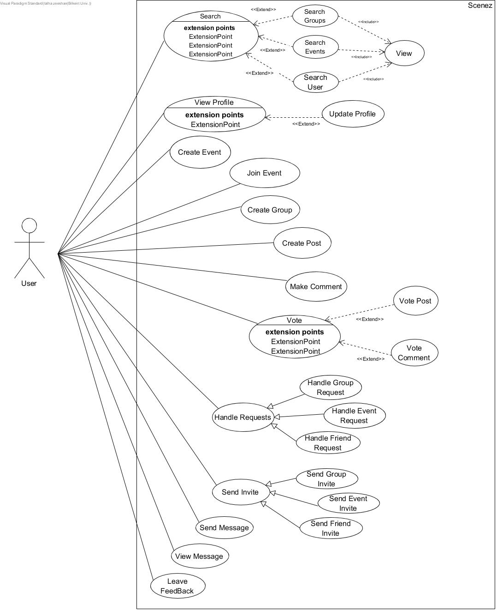

**ii) Group_Admin**

The Group_Admin user type represents the a user of the application who has acquired group administrator privileges by creating their own group. Described below are various additional use case scenarios for such a user of Scenez. The described use case scenarios below for group administrator are limited to within the group of which they are the administrator of.

* **Invite Approvals**

Use Case Name: Handle Requested Invites

Description:

This use case is invoked when the group administrator approves or rejects requested invites of friends of group members. The group administrator is alerted of these requests after a group member successfully invites a friend of theirs to the group. All users not invited by the administrator are subjected to administrator approval (use case invoked).

* **Remove Members**

Use Case Name: Remove Members

Description:

The use case is invoked when the group administrator chooses to remove a group member from the group. The group administrator has the authority to remove any member of the group they see fit. The invoking of this use case results in system revoking membership of said member.

* **View Members**

Use Case Name: View Members

Description:

The group administrator has the authority to view all members that are part of the group. The invoking of this use case results in the system displaying all current members of the group.

* **Message Members**

Use Case Name: Message Members

Description:

The group administrator has the ability to send messages to entire group. The invoking of this use case results in a message being sent to all current members of the group. The message is limited to simple text form.

* **Remove Posts**

Use Case Name: Remove Posts

Description:

The group administrator has the authority to remove any posts made on group events. Upon invoking this use case, the respective post is removed from the group event.

* **Remove Comments**

Use Case Name: Remove Comments

Description:

The group administrator has the authority to remove any comments made on group event posts. Upon invoking this use case, the respective comment is removed from the group event post.

* **Make Comment**

Use Case Name: Make Comment

Description:

The “Make Comment” use case is invoked when the group administrator chooses to comment on specific group event post. The comment is limited to include simple text.

* **Leave a Vote**

Use Case Name: *Vote*

Description:

The “Vote Comment” use case is invoked when the group admin chooses to Upvote or DownVote a comment or post made within said group events.

* **Make Post**

Use Case Name: *Make Post*

Description:

The “Create Post” use case is invoked when the administrator chooses to post to a specific group event. The post content is limited to simple text.

* **Send Invites**

Use Case Name: *Send Invite*

Description:

The “Send Invite” use case is invoked when the group admin chooses to send invitations to his/her friends to join the group. Invitees Invited by the group administrator are exempt from approvals and these invitees can immediately join the group if they reply positively.

* **Update Settings**

Use Case Name: *Update Settings*

Description:

The group administrator has the authority to change group settings(changing name, themes, rules etc). In such a case, this use case is invoked. The system updates the group settings upon successful invoke.

* **Create Group Event**

Use Case Name: *Create Group Event*

Description:

The group administrator has the sole authority to create group events. When invoked, the system provides an interface in which the admin enters relevant details relating to the event (Title, location, description, Date of Event, Theme etc) and chooses whether the event will be public or limited to group members. Furthermore, members of said group are automatically invited to the event upon its creation.

* **Delete Group Event**

Use Case Name: *Delete Group Event*

Description:

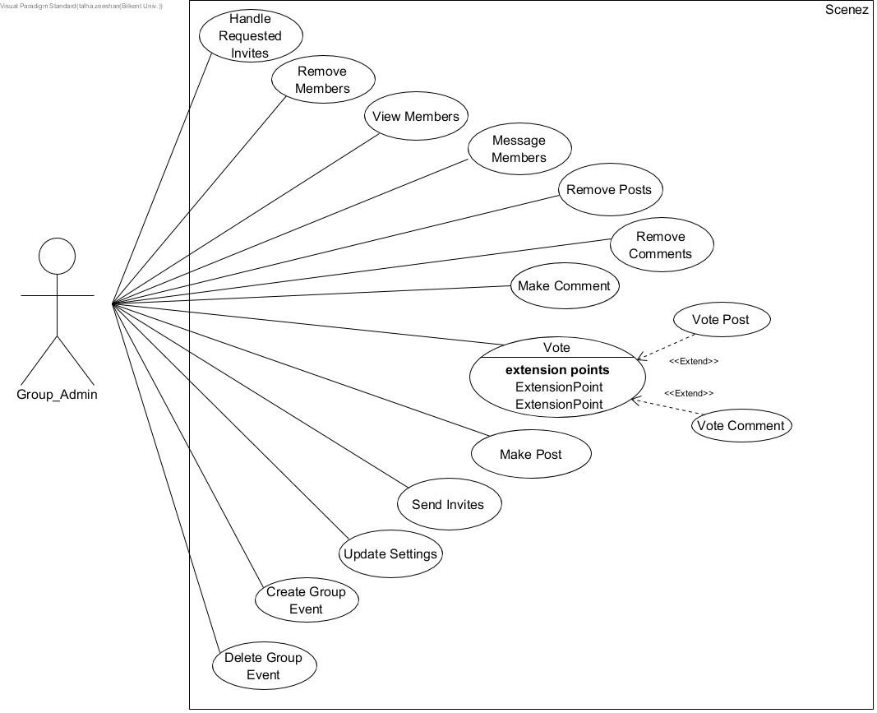The group administrator has the authority to delete any group event. Upon such a request by the group administrator, this use case is invoked in which the event is dedeleted from the group.

Figure 2: Group Administrator Use Case Scenarios

**iii) Event_Host**

The Event_Host user type represents the a user of the application who has acquired event host privileges by creating their own event. Described below are various additional use case scenarios for such a user of Scenez. The described use case scenarios below for event hosts are limited to within the event of which they are the host of.

* **Send Invites**

Use Case Name: *Send Invite*

Description:

The “Send Invite” use case is invoked when the event host chooses to send invitations to his/her friends to join the group. Invitees invited by the host are exempt from approvals and invitees can immediately join the group if they reply positively (in the case of Events being invite only).

* **Handle Requests**

Use Case Name: Handle Requested Invites

Condition: Event is Invite Only

Description:

This use case is invoked when the event host approves or rejects requested invites of friends of event participants. The event host is alerted of these requests after a attendant successfully invites a friend of theirs to the event. All users not invited by the host are subjected to host approval (use case invoked).

* **View Participants**

Use Case Name: View Members

Description:

The event host has the authority to view all participants of the event. The invoking of this use case results in the system displaying all current participants of the event.

* **Update Settings**

Use Case Name: *Update Settings*

Description:

The event host has the authority to change event settings(changing name, themes, location, start time etc). In such a case, this use case is invoked. The system updates the event settings upon successful invocation.

* **View Feedback**

Use Case Name: *View Feedback*

Description:

By invoking this use case, the event host can view feedback related to their event. Upon invocation, the system will display ratings and feedbacks given by attendants of the event.

* **Remove Posts**

Use Case Name: Remove Posts

Description:

The event host has the authority to remove any posts made on their event. Upon invoking this use case, the respective post is removed from the event.

* **Remove Comments**

Use Case Name: Remove Comments

Description:

The event host has the authority to remove any comments made on event posts. Upon invoking this use case, the respective comment is removed from the event post.

* **Make Comment**

Use Case Name: Make Comment

Description:

The “Make Comment” use case is invoked when the event host chooses to comment on specific post in their event. The comment is limited to include simple text.

* **Vote**

Use Case Name: *Vote*

Description:

The “Vote Comment” use case is invoked when the host chooses to Upvote or DownVote a comment or post made within their event(s).

* **Make Post**

Use Case Name: *Make Post*

Description:

The “Create Post” use case is invoked when the host chooses to post to their event(s). The post content is limited to simple text.

* **Delete Event**

Use Case Name: *Delete Group Event*

Description:

The host has the authority to delete any of their event(s). Upon such a request by the host, this use case is invoked in which the event is deleted.

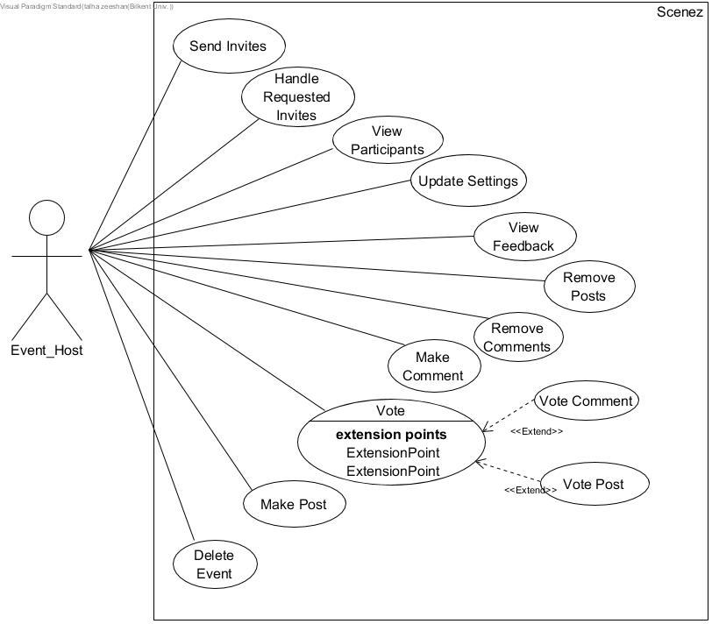

Figure 3: Event Host Use Case Scenarios

## **4.2 Algorithms**

## **4.3 Data Structures**

# **User-Interface Design and corresponding SQL statements**

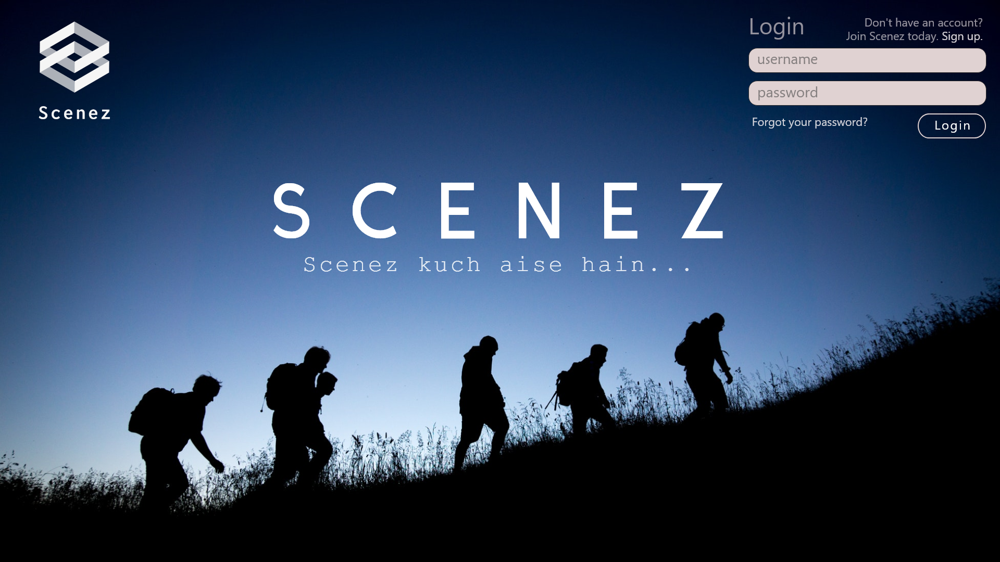

Figure 1 Landing Page

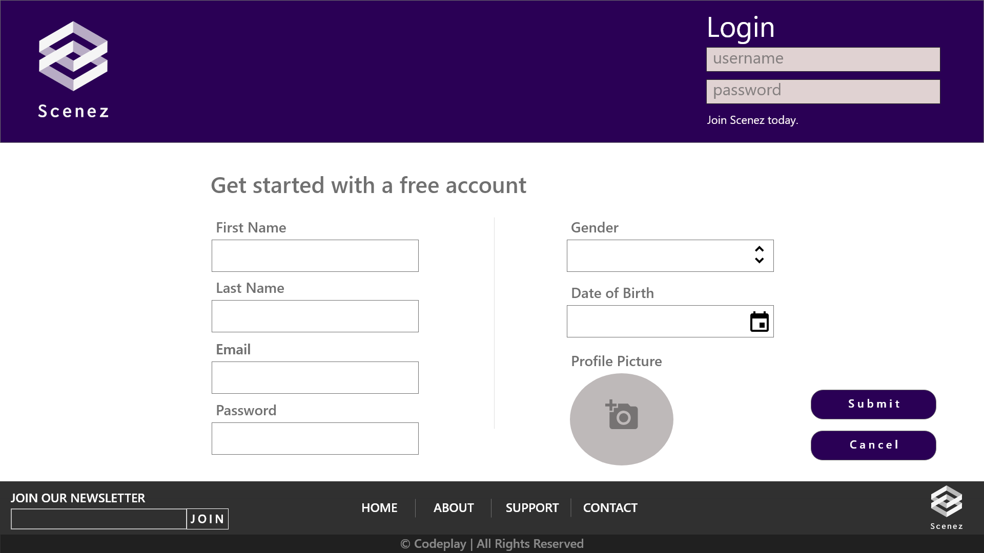

Figure 2 Sign up Page

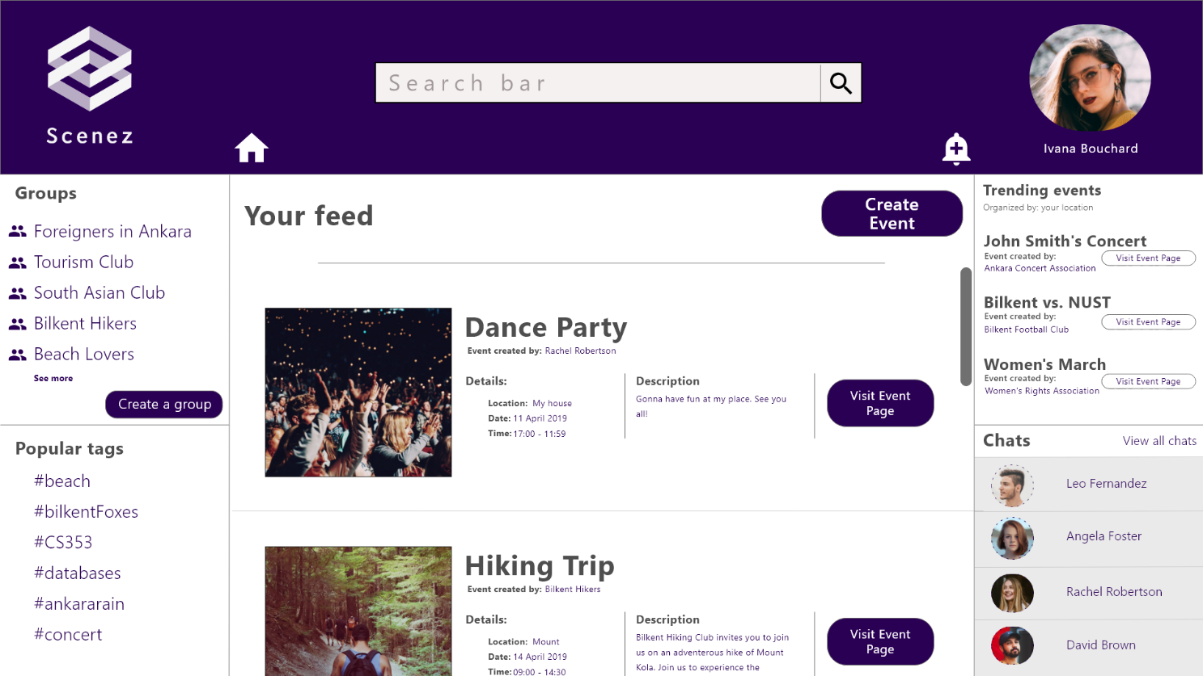

Figure 3 Main Feed

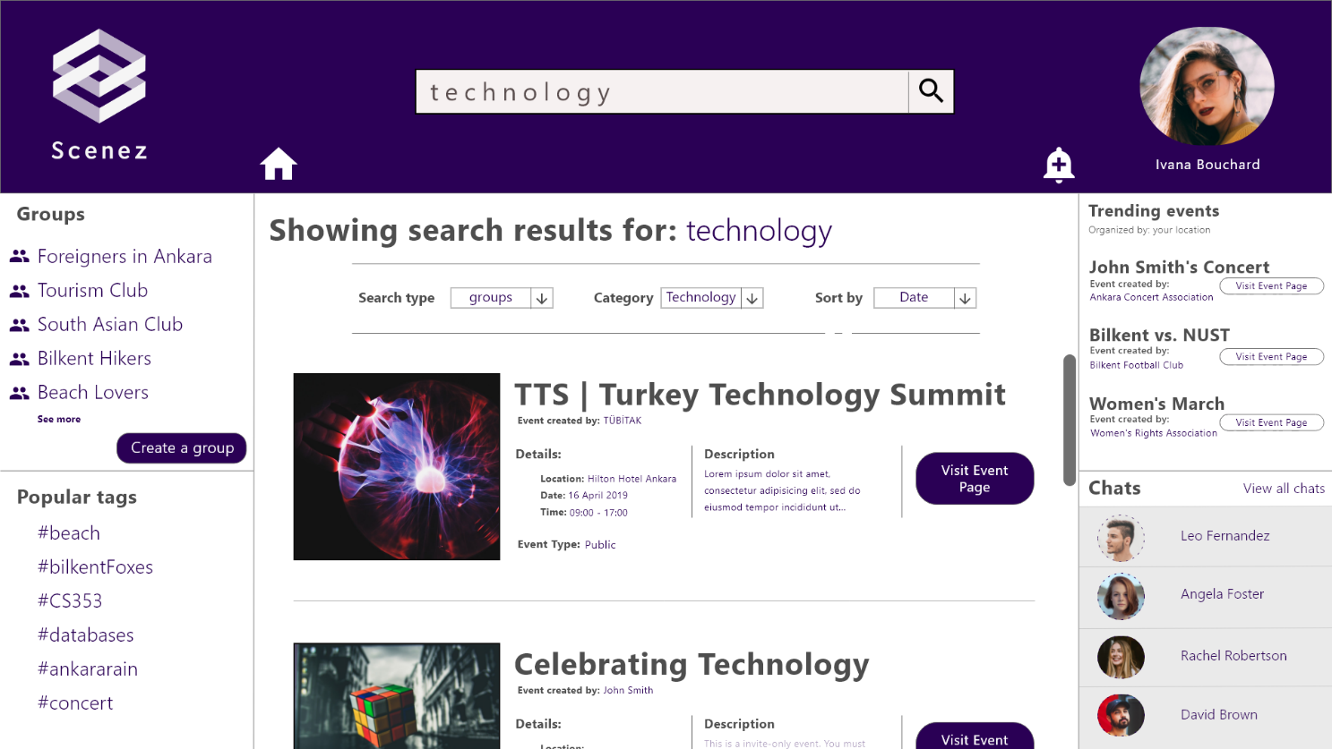

Figure 4 Search Results

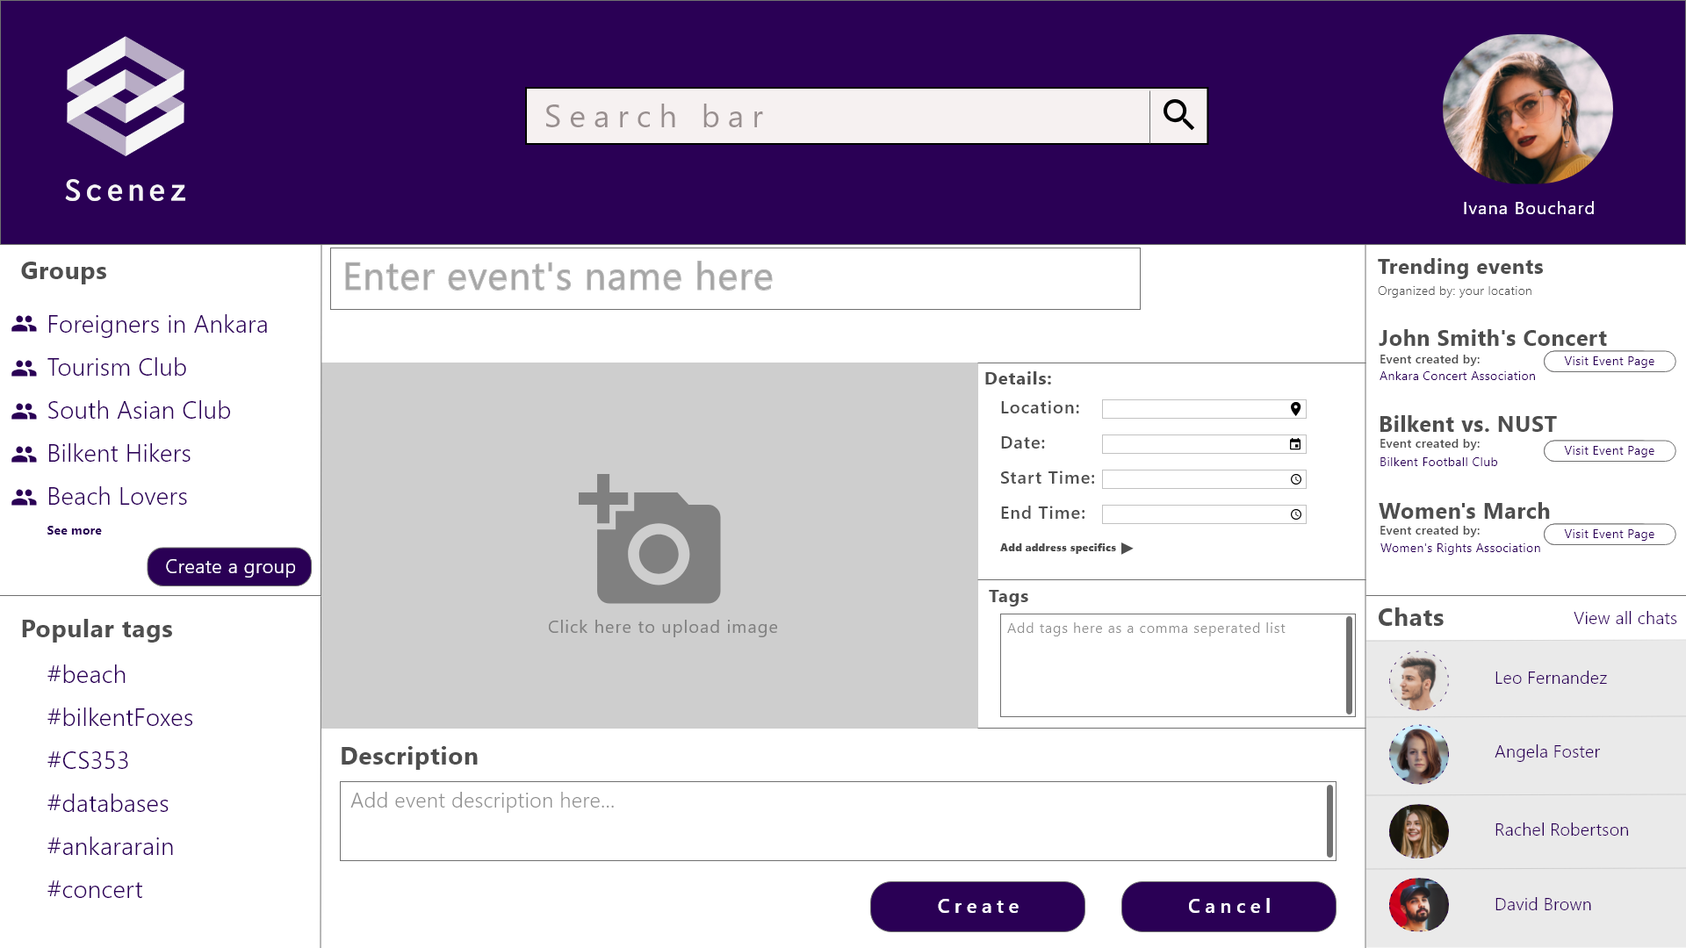

Figure 5 Create Event

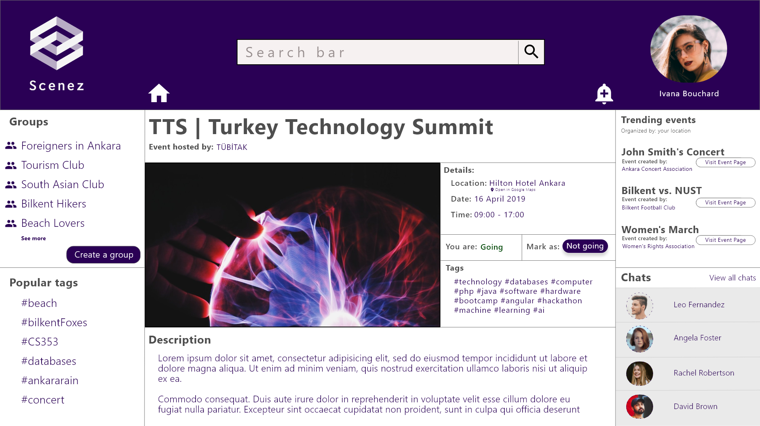

Figure 6 Event View

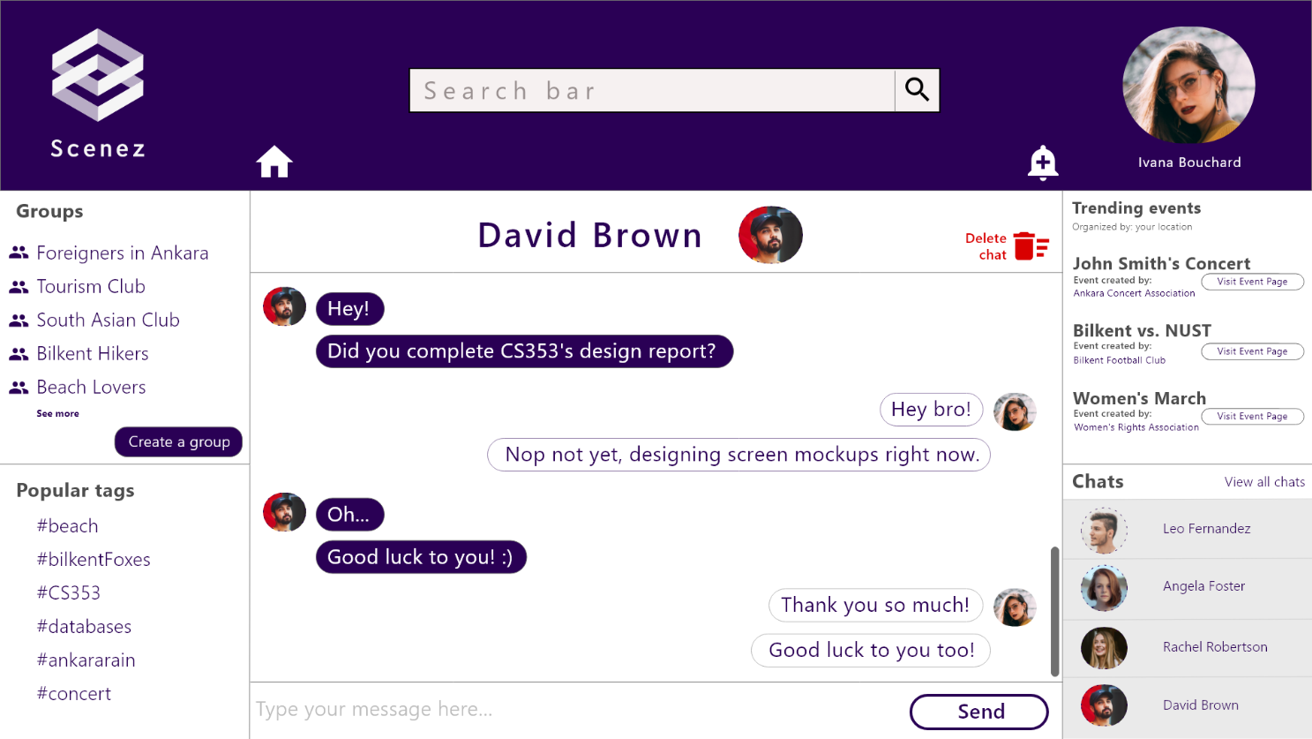

Figure 7 Chat

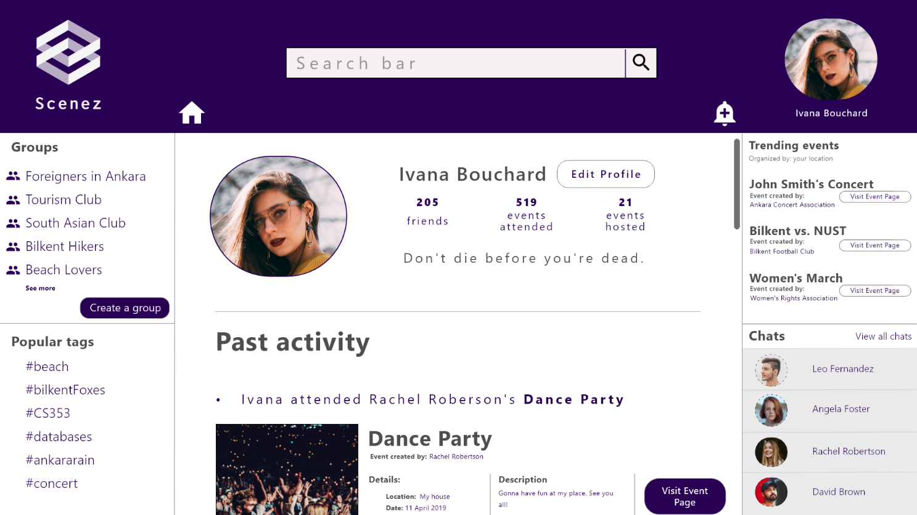

Figure 8 User Profile

# **Advanced Database Components**

# **Implementation Plan**

# **Website**